CS526 O2

Homework Assignment 5

**Problem 1 (10 points)**. Consider the following binary search tree:



26



43



10



15



5



38



47



12



31



25



40

Show the resulting tree if you add the entry with key = 13 to the above tree. You need to describe, step by step, how the resulting tree is generated.

**Answer:**

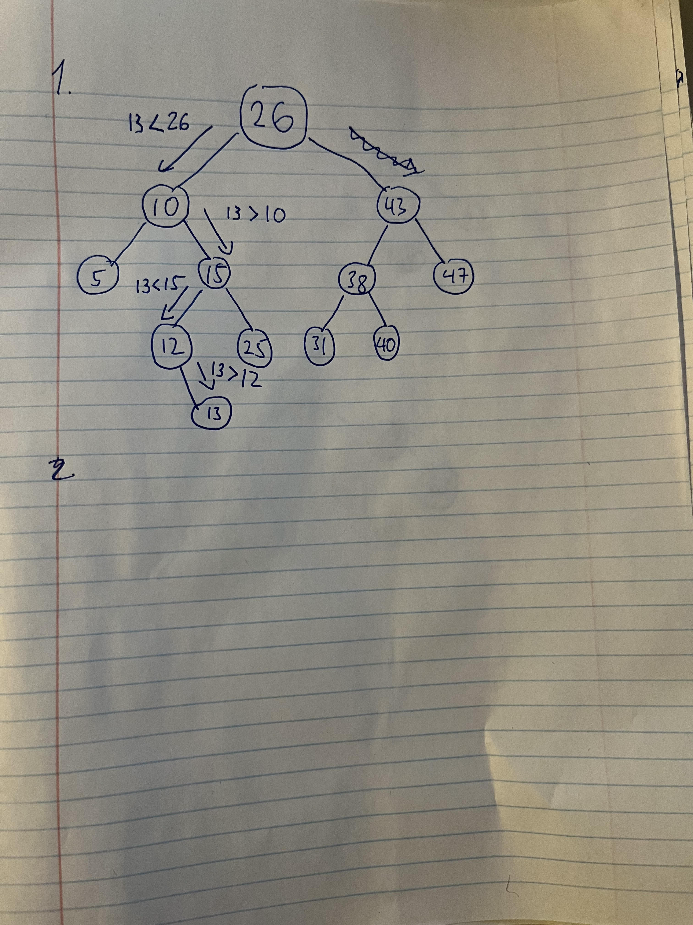

**Problem 2 (10 points)**. Consider the following binary search tree:



42



57



24



30



12



44



63



29



36



31



49

Show the resulting tree if you delete the entry with key = 42 from the above tree. You need to describe, step by step, how the resulting tree is generated.

**Answer:**

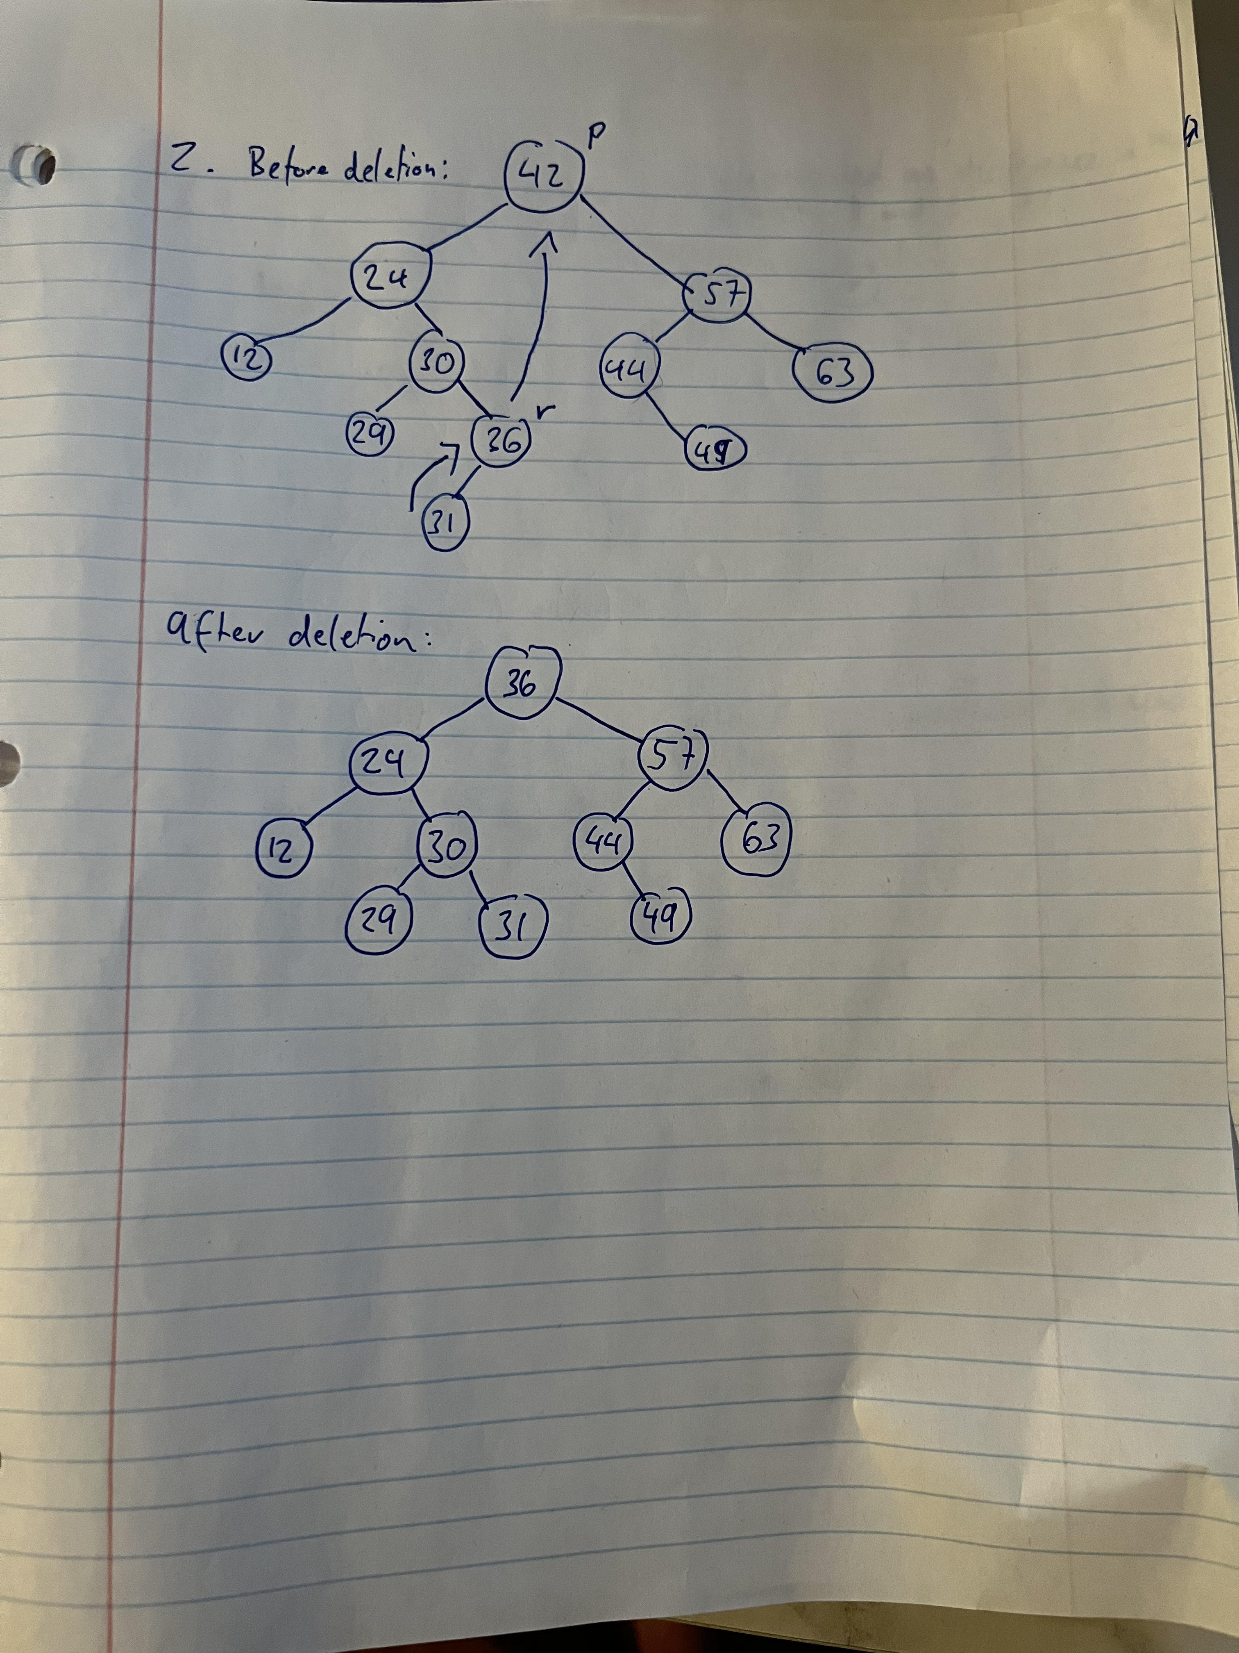

**Problem 3 (10 points).** Consider the following AVL tree, which is unbalanced:



F



G



B



A



D



C



E

z

y

x

Note that the nodes *F*, *B* and *D* are labeled *z*, *y*, and *x*, respectively, following the notational convention used in the textbook. Apply a trinode restructuring on the tree and show the resulting, balanced tree.

**Answer:**

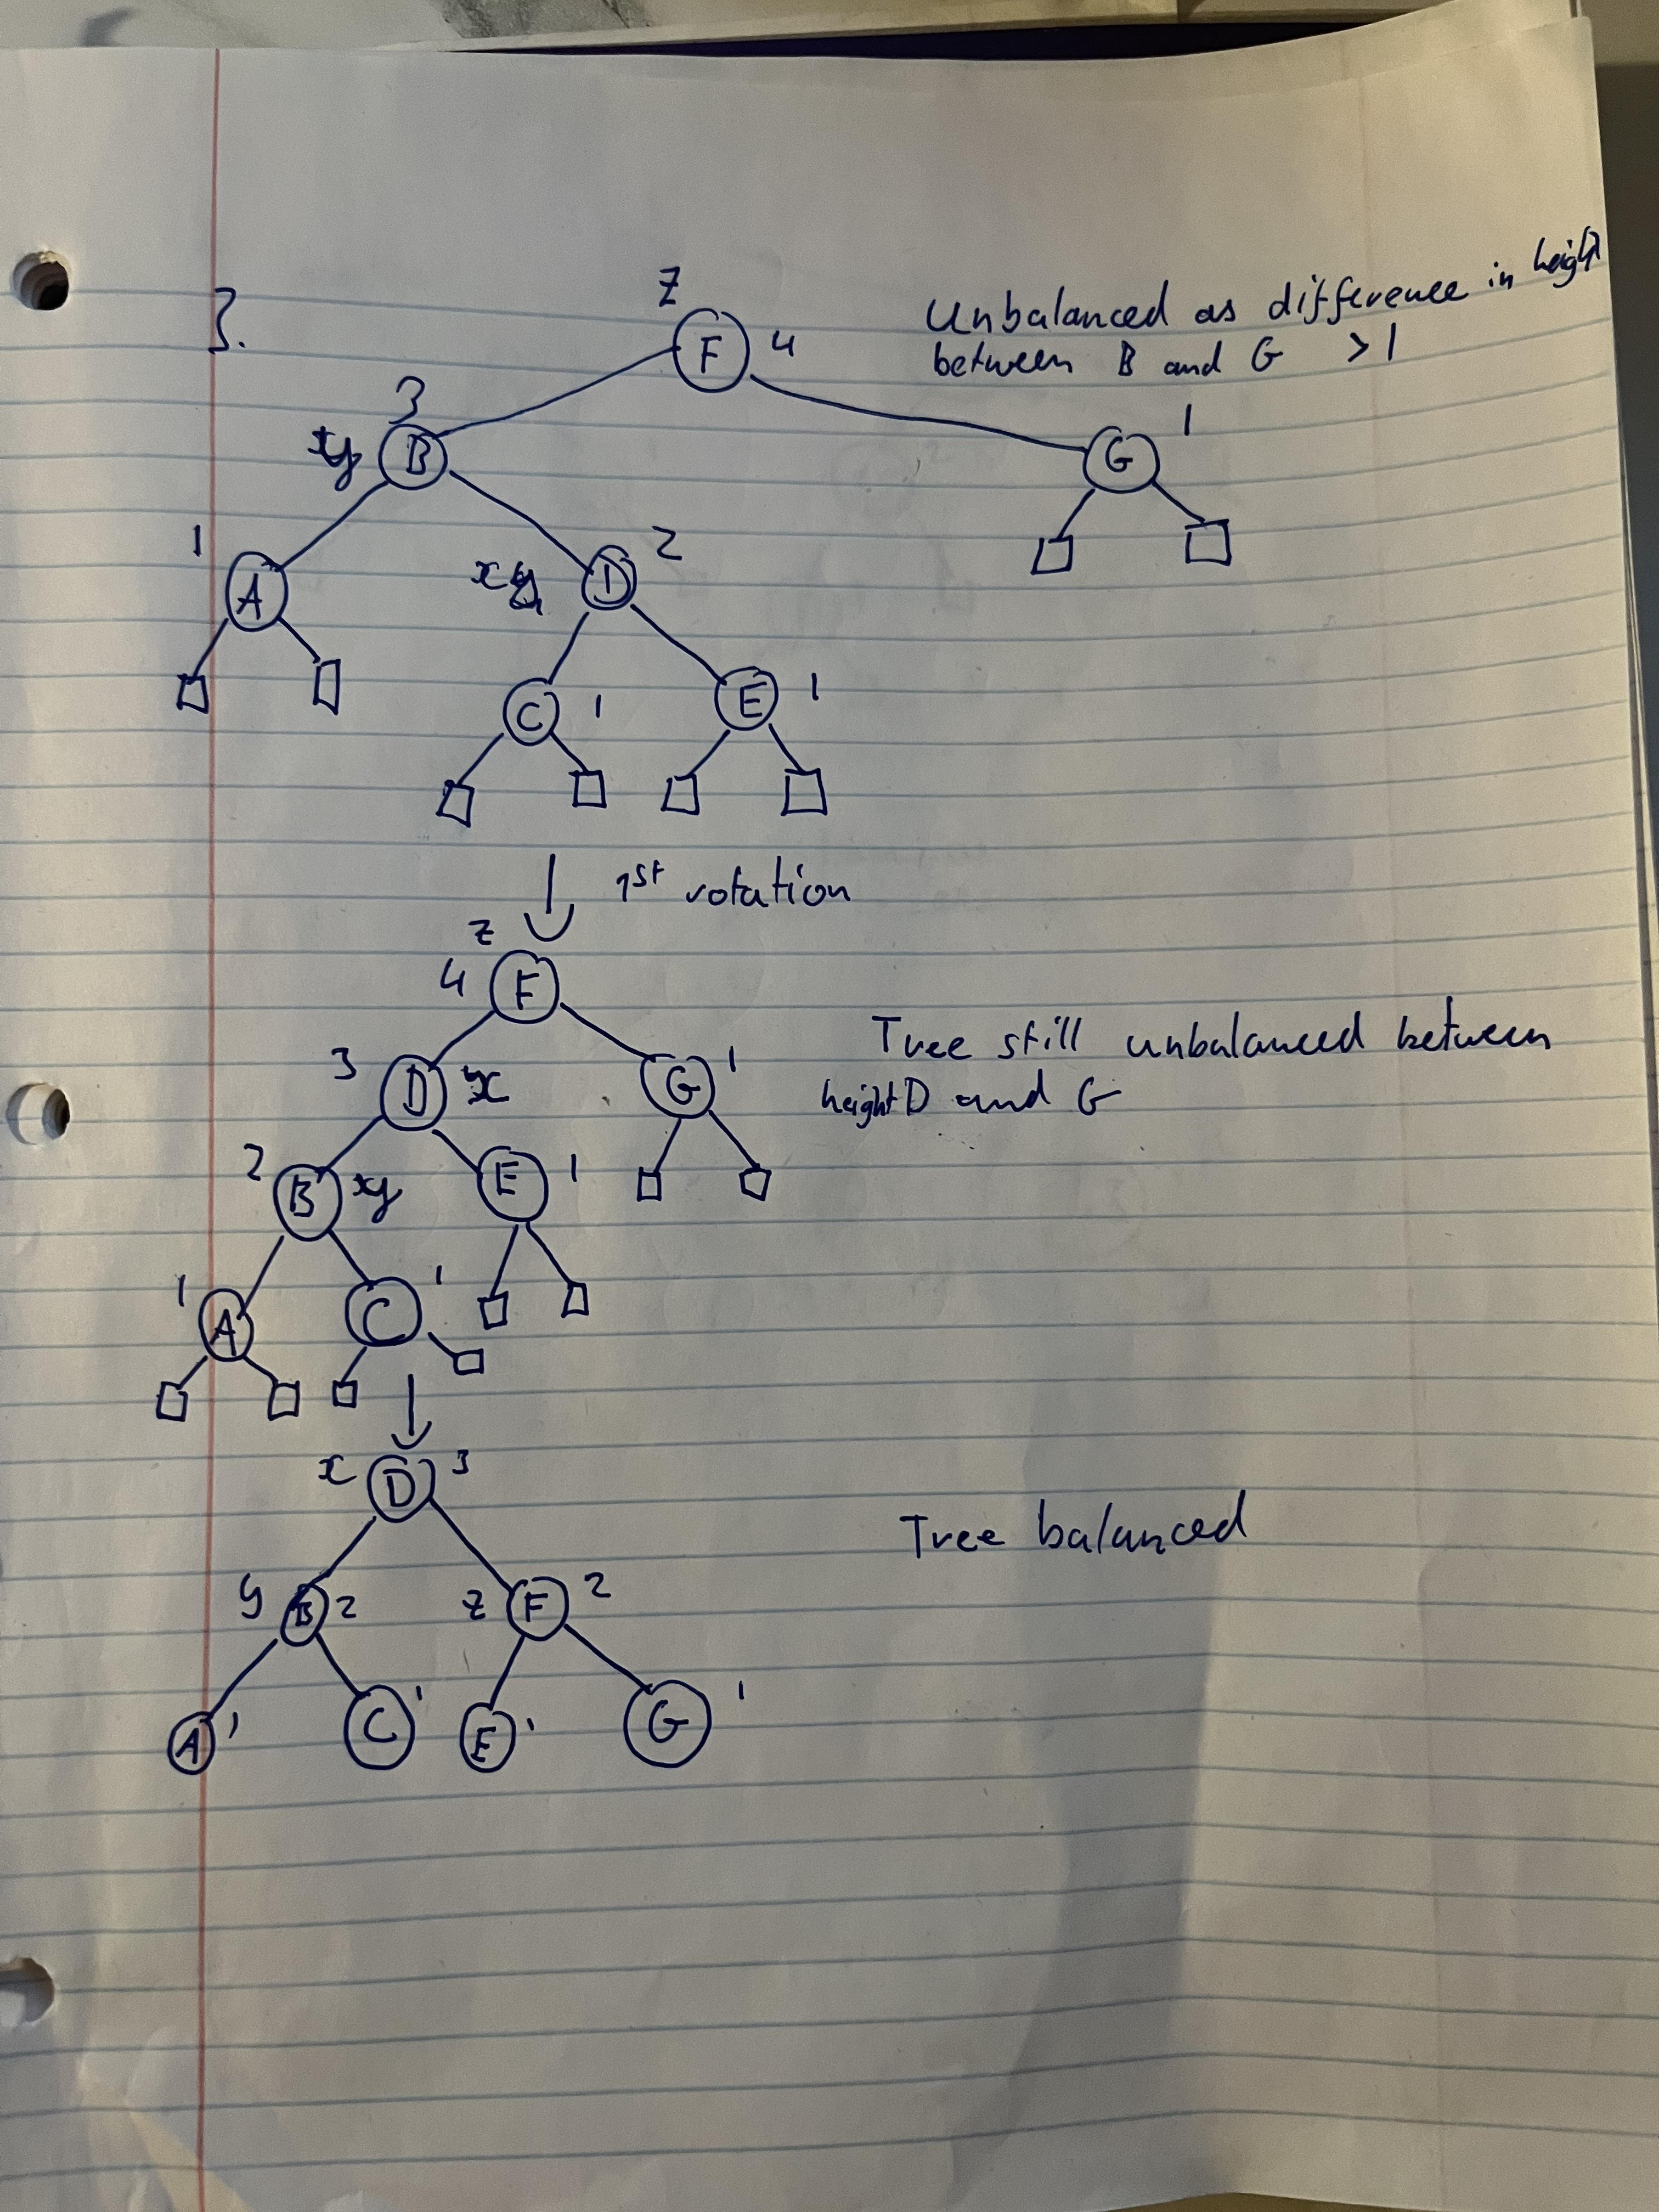

**Problem 4 (10 points)**. Consider the following AVL tree.



21



42



12



6



14



35



59



50



63



31

Show the resulting, balanced tree after inserting an entry with key = 54 to the above tree. You must describe, step by step, how the resulting tree is obtained.

Answer:

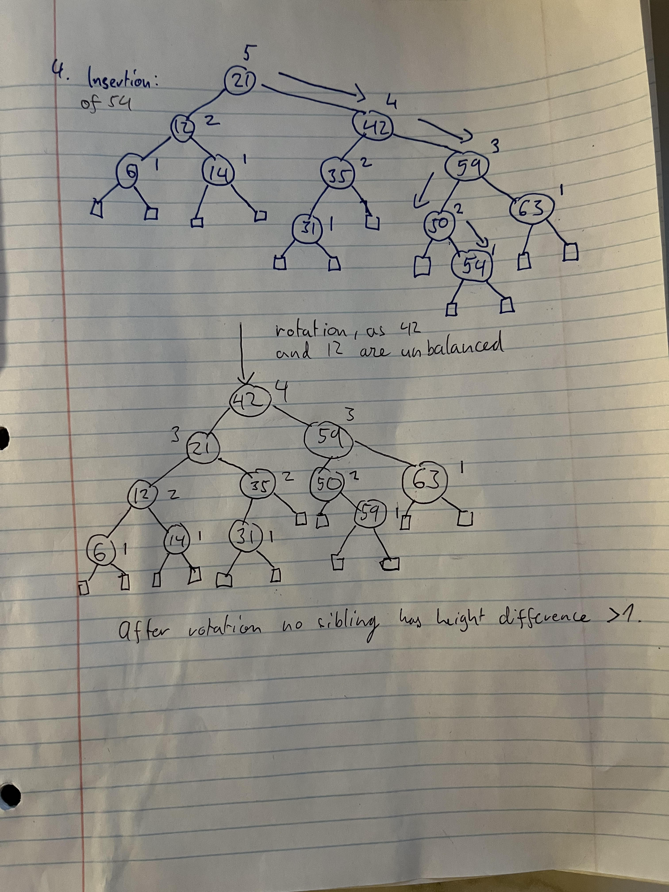

**Problem 5 (10 points).** Consider the following Huffman tree:



79



45



34



18



25



13

C:16

E:8

D:10

G:20

F:12

A:6

B:7

1. Encode the string “BDEGC” to a bit pattern using the Huffman tree.
2. Decode the bit pattern “010111010011” to the original string using the Huffman tree.

Answer:

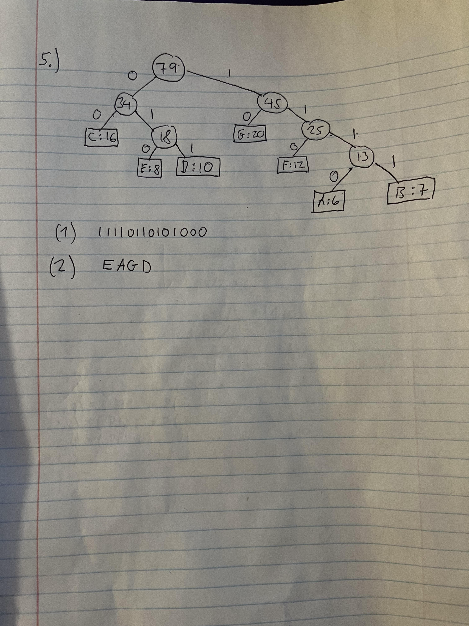

**Problem 6 (10 points).** This question is about the *World Series* problem that we discussed in the class. The following is the probability matrix for the problem.

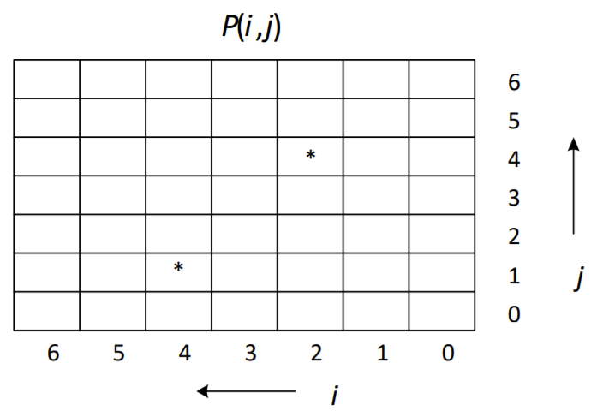

Calculate the probabilities of *P*(4, 1) and *P*(2, 4), which are marked with *. You must show all intermediate steps and calculations.

Answer:

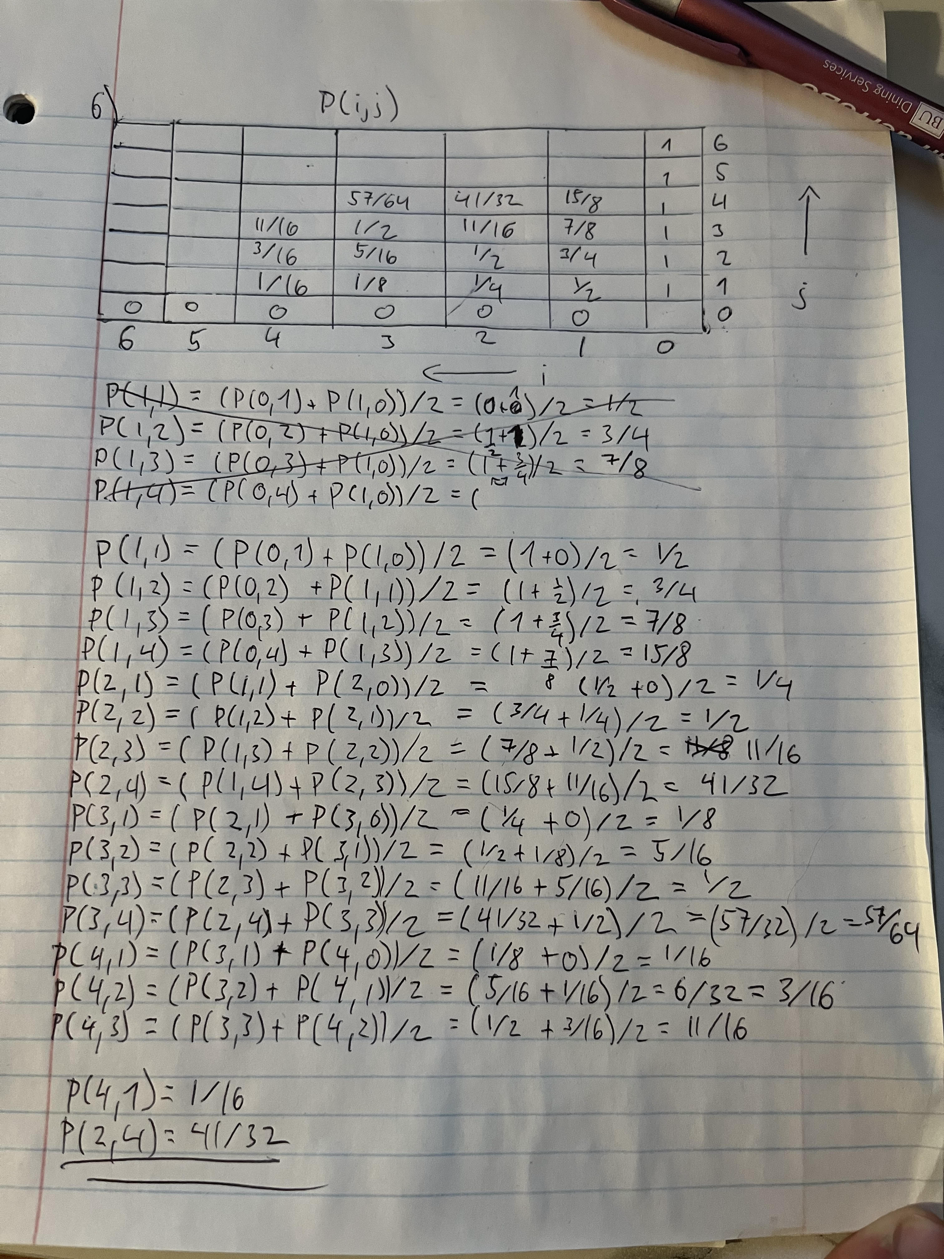

**Problem 7: Answer:**

|  |  |  |  |  |  |  |  |  |  |  |
| --- | --- | --- | --- | --- | --- | --- | --- | --- | --- | --- |
| *n*  *Algorithm* | 10000 | 20000 | 30000 | 40000 | 50000 | 60000 | 70000 | 80000 | 90000 | 100000 |
| insertion | 49 | 177 | 94 | 167 | 265 | 383 | 520 | 692 | 878 | 1089 |
| merge | 112 | 27 | 28 | 33 | 26 | 26 | 26 | 34 | 33 | 33 |
| quick | 43 | 73 | 96 | 99 | 34 | 24 | 21 | 24 | 21 | 25 |
| heapsort | 10 | 9 | 10 | 9 | 10 | 9 | 10 | 11 | 9 | 9 |

*Table 1*

*Graph1*

Table 1 and Graph1 show the runtime(in ms) of each sort with n entries. Insertion sort has noticeably the largest run time, as expected. The worst case run time for insertion sort is O(n2), which is the highest out of all the sorting algorithms examined. The worst case runtime of: merge sort is O(nlogn), quick sort has O(n2) (however the worst case for quick sort occurs only when the elements to be sorted are in a decreasing/ increasing order, therefore not our case) and heap sort is O(nlogn). The average running time of quick,merge and quick sort is O(nlog(n)), therefore the running times are very similar and the bigger # n don’t have a significant impact on the runtime because it is O(nlogn). The difference between heap and merge sort is that merge sort is slightly faster, however it requires twice as many space in memory because it is implementing a second array.